**Resource group and tags:**

Create resource group

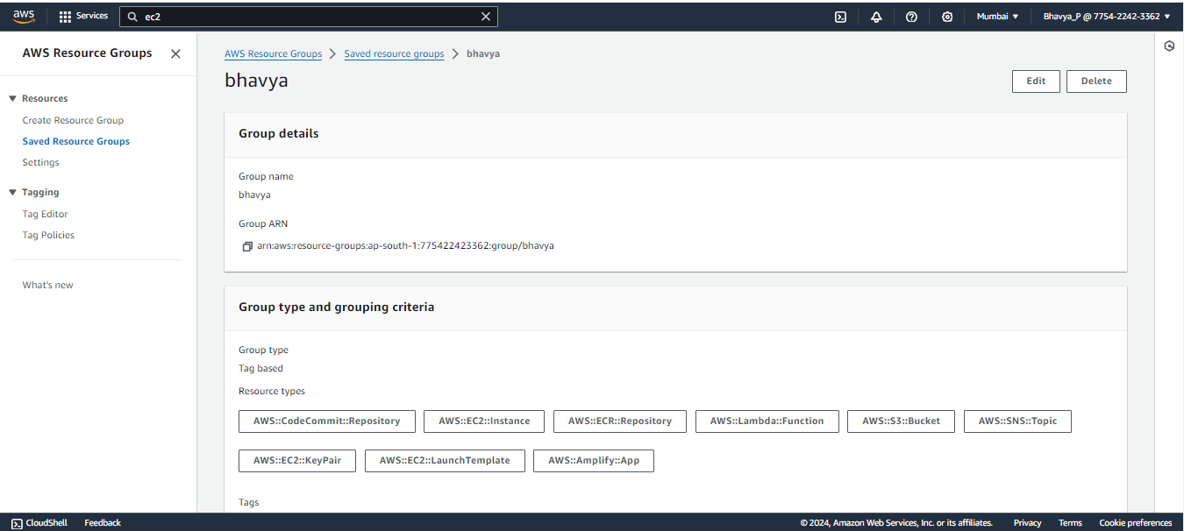

Choose group type: tag based  
add all the resource types which you have used and add the tag(key and value)

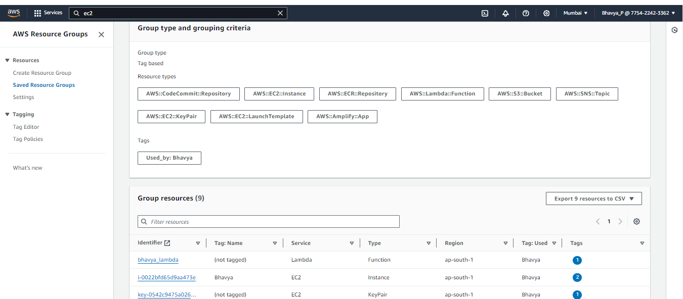

Preview all the resources  
it would show all the resources which have that tag

